healthcare_ehr | SBP
V1.0

Revision History
Version | Date | Description | Author
1.0 | 17/02/2026 | Initial Version | Mohammed Megahed

Reviewers
# | Name | Position | Date and Signature
1
2

Acceptance and Signoff
# | Name | Position | Date and Signature
1
2

Contents
1. Introduction 5
1.1. Project Summary 5
1.2. In-Scope 5
1.3. Out-Scope 5
1.4. Target Audience 5
1.5. Abbreviations 5
1.6. Assumptions, Dependencies and Risks 6
1.7. Impact Questionnaire 6
2. Requirements Compliancy Matrix 6
3. Solution Architecture 7
3.1. Solution Description 7
3.2. Non-Functional Requirements 8
3.3. Security Considerations 8
4. Patient Clinical Encounter 9
4.1. Sequence Diagram 9
4.2. Flow Description 9
4.3. State Machine Diagram 12
4.4. APIs Contract Agreement 14
4.5. Error Handling 15
5. Electronic Prescription (e-Prescribing) 18
5.1. Sequence Diagram 18
5.2. Flow Description 19
5.3. State Machine Diagram 21
5.4. APIs Contract Agreement 22
5.5. Error Handling 22
6. Appendix 26
6.1. Patient Clinical Encounter Data Elements 26
6.2. Electronic Prescription (e-Prescribing) Data Elements 27
6.3. Solution Architecture Reference Documents 27

1. Introduction

1.1. Project Summary
This project delivers an Electronic Health Records system for hospitals to centralize patient registration, demographics, clinical documentation, problem lists, allergy management, laboratory orders, and electronic prescribing with drug interaction checks, addressing fragmented patient data and manual processes. Key capabilities include integrated clinical notes, diagnosis coding, lab order management, and seamless exchange of diagnostic information with laboratory and radiology systems. This enables clinicians to access complete and accurate patient records, improving care quality and operational efficiency.

1.2. In-Scope
# | Item
1. | Patient registration and demographics
2. | Clinical documentation (notes, assessments)
3. | Problem list and allergy management
4. | Laboratory order placement and results
5. | Electronic prescribing with drug interaction checking
6. | Appointment scheduling
7. | Clinical decision support alerts

1.3. Out-Scope
# | Item
1. | Hospital billing and revenue cycle
2. | Inventory and supply chain management
3. | Human resources management
4. | Telemedicine video consultations

1.4. Target Audience
# | Stakeholders
1. | Enterprise Architects
2. | Partners and Vendors Technical Leaders
3. | Infrastructure Architects & Engineers
4. | InfoSec Architects & Engineers
5. | Technical Managers
6. | Delivery Leads and Project Managers
7. | Developers

1.5. Abbreviations
# | Abbreviations | Full form
1

1.6. Assumptions, Dependencies and Risks
# | Item | Type | Owner | Comment
1.
2.

2. Requirements Compliancy Matrix
ID. | Title | Description | Compliancy | Comments
FR-1 | MediCare is a comprehensive Electronic Health Records system for hospitals and c | MediCare provides hospitals and clinics with a complete electronic health records solution to support efficient patient care, accurate recordkeeping, and regulatory compliance. | Compliant
FR-2 | The platform supports clinical documentation, order management, and e-prescribin | The platform enables users to document clinical information, manage orders, and prescribe medications electronically to support efficient and accurate patient care. | Compliant
FR-3 | Integration with laboratory and radiology systems provides complete diagnostic w | The solution enables seamless access to laboratory and radiology results, supporting a complete and efficient diagnostic workflow for users. | Compliant
FR-BR-001 | Patient Registration | Patients provide required personal and health information to register before receiving services, ensuring accurate records and compliance with regulatory standards. | Compliant
FR-BR-002 | Medical History | The organization collects and maintains accurate medical history information to ensure appropriate care, support decision-making, and meet regulatory requirements. | Compliant
FR-BR-003 | Clinical Notes | Clinical notes are recorded and maintained to accurately document patient care, support clinical decision-making, and ensure compliance with healthcare regulations. | Compliant
FR-BR-004 | Diagnosis Coding | All diagnoses are accurately coded using approved standards to ensure correct billing, reporting, and regulatory compliance. | Compliant
FR-BR-005 | Lab Orders | Users can create, manage, and track lab orders to ensure accurate and timely processing of laboratory tests. | Compliant
FR-BR-006 | e-Prescribing | The organization enables healthcare providers to electronically send prescriptions to pharmacies, reducing errors and improving efficiency in medication management. | Compliant
FR-BR-007 | Drug Interactions | The system alerts users to potential drug interactions to support safe medication management and reduce the risk of adverse health outcomes. | Compliant
FR-BR-008 | Scheduling | Users can schedule activities or services at preferred times to ensure efficient planning and resource allocation. | Compliant
FR-BR-009 | lerts | The system provides timely alerts to users to support informed decision-making and promote compliance with clinical guidelines. | Compliant
FR-BR-010 | Audit Trail | Maintain a complete and accurate record of all user actions and changes to support accountability, transparency, and regulatory compliance. | Compliant

3. Solution Architecture

3.1. Solution Description
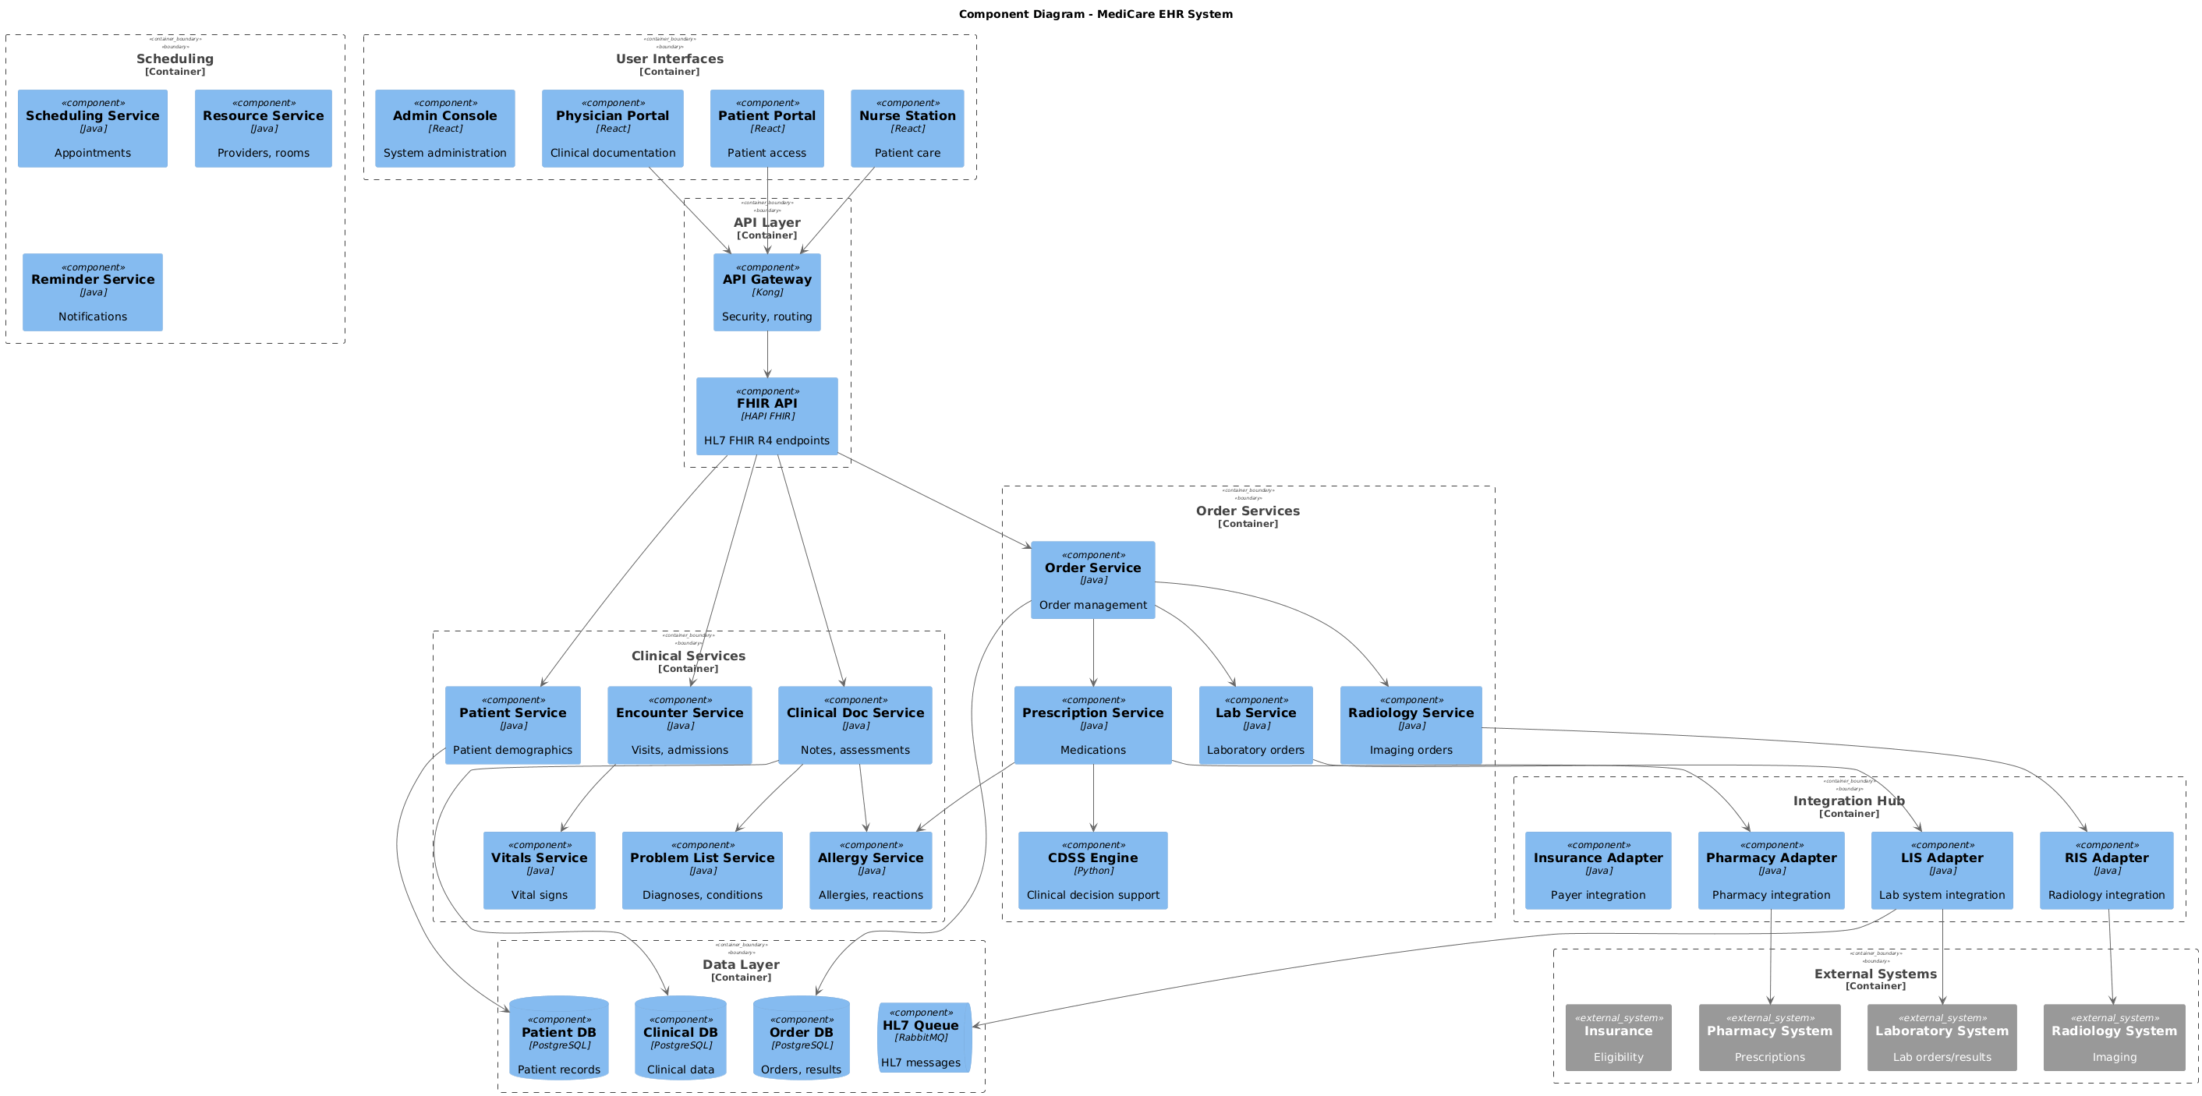

3.2. Non-Functional Requirements
# | Category | Requirement | Target/SLA
1 | Performance | API Response Time | < 2 seconds for 95th percentile
2 | Performance | Transaction Throughput | Support 100 TPS during peak hours
3 | Availability | System Uptime | 99.9% availability (excluding planned maintenance)
4 | Availability | Recovery Time Objective (RTO) | < 4 hours
5 | Availability | Recovery Point Objective (RPO) | < 1 hour
6 | Scalability | Horizontal Scaling | Support auto-scaling based on load
7 | Scalability | Concurrent Users | Support 1000 concurrent users
8 | Data Retention | Transaction Logs | Retain for 7 years as per regulatory requirements
9 | Data Retention | Audit Logs | Retain for 5 years
10 | Compliance | Regulatory | Comply with CMA and SAMA regulations
11 | Compliance | Data Protection | Comply with data privacy requirements

3.3. Security Considerations
# | Security Domain | Requirement | Implementation
1 | Authentication | User Authentication | OAuth 2.0 / JWT tokens with secure token storage
2 | Authentication | Service-to-Service Auth | Mutual TLS (mTLS) for internal service communication
3 | Authentication | Multi-Factor Authentication | MFA required for sensitive operations
4 | Authorization | Role-Based Access Control | RBAC implemented with principle of least privilege
5 | Authorization | API Authorization | Scope-based access control for API endpoints
6 | Data Protection | Data in Transit | TLS 1.2+ encryption for all network communication
7 | Data Protection | Data at Rest | AES-256 encryption for sensitive data storage
8 | Data Protection | PII/Sensitive Data | Data masking and tokenization for sensitive fields
9 | API Security | Input Validation | Server-side validation of all input parameters
10 | API Security | Rate Limiting | Rate limiting to prevent abuse and DDoS attacks
11 | API Security | CORS Policy | Strict CORS policy for web API endpoints
12 | Audit & Logging | Audit Trail | Log all security-relevant events with timestamps
13 | Audit & Logging | Log Protection | Immutable logs with tamper detection
14 | Vulnerability Management | Security Scanning | Regular SAST/DAST scanning in CI/CD pipeline
15 | Vulnerability Management | Dependency Scanning | Automated scanning for vulnerable dependencies

4. Patient Clinical Encounter

4.1. Sequence Diagram
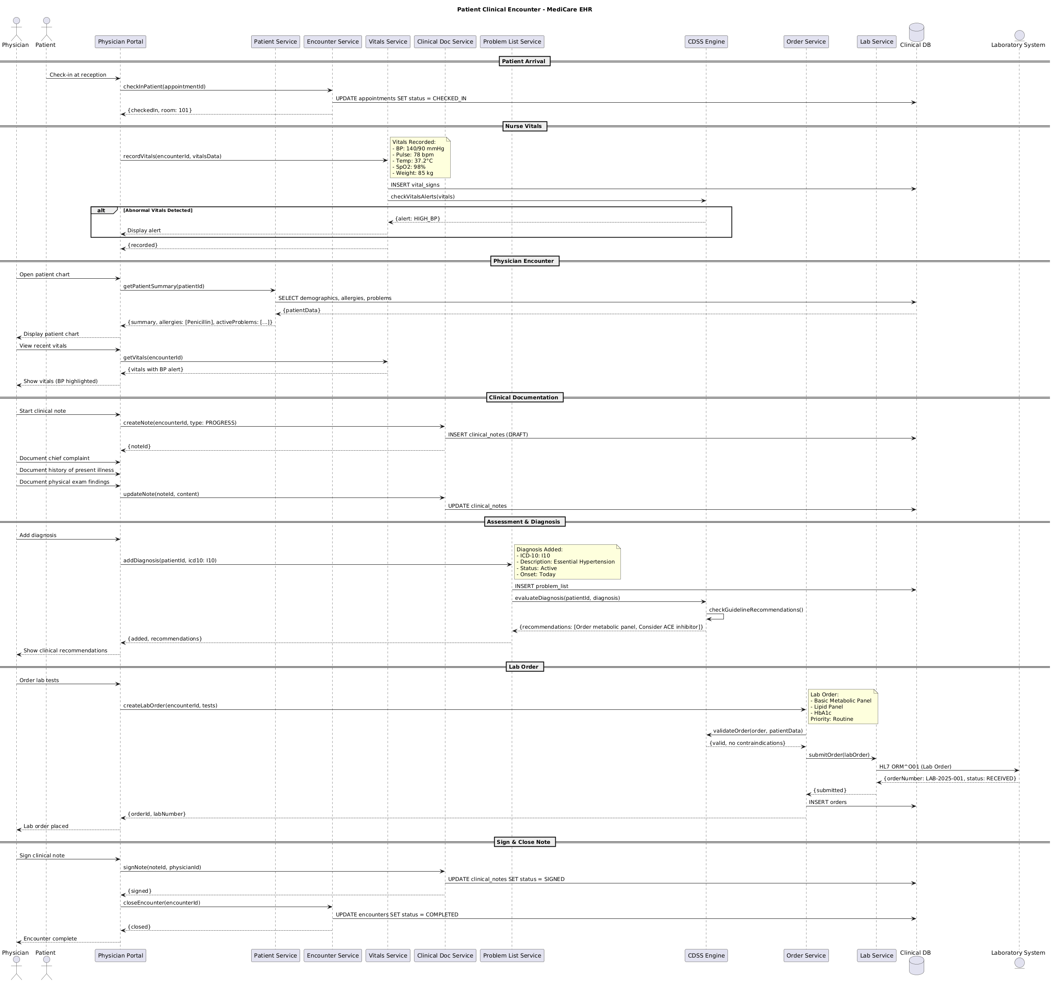

4.2. Flow Description
  - Overview
This flow describes the end-to-end process for a patient clinical encounter within the MediCare EHR ecosystem. The flow covers patient check-in, nurse vitals collection, physician review, clinical documentation, diagnosis, lab ordering, and encounter closure. The main actors and systems involved are Physician, Patient, Physician Portal, Patient Service, Encounter Service, Vitals Service, Clinical Doc Service, Problem List Service, CDSS Engine, Order Service, Lab Service, Clinical DB, and Laboratory System. Each participant plays a specific role in managing patient data, clinical workflows, and integrations with ancillary systems.
  - Process Flow
Patient Arrival
The process begins when Patient checks in at reception through Physician Portal. Physician Portal initiates the patient check-in by sending a request to Encounter Service with the appointment identifier. Encounter Service updates the appointment status to 'CHECKED_IN' in Clinical DB. After updating, Encounter Service returns a confirmation to Physician Portal with the checked-in status and assigned room number 101.
Nurse Vitals
Physician Portal sends a request to Vitals Service to record the patient's vitals, providing the encounter identifier and vitals data.
Note: Vitals Recorded:
- BP: 140/90 mmHg
- Pulse: 78 bpm
- Temp: 37.2°C
- SpO2: 98%
- Weight: 85 kg
Vitals Service records the vitals by inserting the data into Clinical DB. Next, Vitals Service requests CDSS Engine to check for any alerts based on the recorded vitals.
If abnormal vitals are detected, CDSS Engine responds to Vitals Service with an alert indicating high blood pressure. Vitals Service then notifies Physician Portal to display the alert. Otherwise, this alert step is skipped.
After processing, Vitals Service confirms to Physician Portal that the vitals have been recorded.
Physician Encounter
Physician opens the patient chart using Physician Portal. Physician Portal requests a patient summary from Patient Service, providing the patient identifier. Patient Service retrieves demographics, allergies, and active problems from Clinical DB and returns the patient data to Physician Portal. Physician Portal then presents the patient chart to Physician.
Physician requests to view recent vitals through Physician Portal. Physician Portal queries Vitals Service for the encounter's vitals. Vitals Service returns the vitals, including any blood pressure alert, to Physician Portal. Physician Portal displays the vitals to Physician, highlighting the blood pressure value if an alert is present.
Clinical Documentation
Physician starts a clinical note in Physician Portal. Physician Portal creates a new note in Clinical Doc Service, specifying the encounter and note type as 'PROGRESS'. Clinical Doc Service inserts a draft clinical note into Clinical DB and returns the note identifier to Physician Portal.
Physician documents the chief complaint, history of present illness, and physical exam findings in Physician Portal. Physician Portal updates the clinical note in Clinical Doc Service with the new content. Clinical Doc Service updates the corresponding clinical note in Clinical DB.
Assessment & Diagnosis
Physician adds a diagnosis using Physician Portal. Physician Portal sends the diagnosis information, including the patient identifier and ICD-10 code I10, to Problem List Service.
Note: Diagnosis Added:
- ICD-10: I10
- Description: Essential Hypertension
- Status: Active
- Onset: Today
Problem List Service inserts the new diagnosis into the problem list in Clinical DB. It then requests CDSS Engine to evaluate the diagnosis for clinical decision support. CDSS Engine internally performs an operation to check guideline recommendations. CDSS Engine responds to Problem List Service with recommendations, such as ordering a metabolic panel and considering an ACE inhibitor. Problem List Service returns the confirmation and recommendations to Physician Portal. Physician Portal displays the clinical recommendations to Physician.
Lab Order
Physician orders lab tests through Physician Portal. Physician Portal creates a lab order in Order Service, providing the encounter identifier and requested tests.
Note: Lab Order:
- Basic Metabolic Panel
- Lipid Panel
- HbA1c
Priority: Routine
Order Service requests CDSS Engine to validate the order against patient data. CDSS Engine confirms the order is valid and there are no contraindications. Order Service submits the lab order to Lab Service. Lab Service sends the order to Laboratory System using the HL7 ORM^O01 message format. Laboratory System acknowledges receipt of the order with an order number and status. Lab Service confirms submission to Order Service. Order Service inserts the order into Clinical DB and returns the order identifier and lab number to Physician Portal. Physician Portal notifies Physician that the lab order has been placed.
Sign & Close Note
Physician signs the clinical note in Physician Portal. Physician Portal requests Clinical Doc Service to sign the note, providing the note identifier and physician identifier. Clinical Doc Service updates the note status to 'SIGNED' in Clinical DB and confirms the signature to Physician Portal.
Physician Portal then requests Encounter Service to close the encounter, providing the encounter identifier. Encounter Service updates the encounter status to 'COMPLETED' in Clinical DB and confirms closure to Physician Portal. Finally, Physician Portal informs Physician that the encounter is complete.

4.3. State Machine Diagram
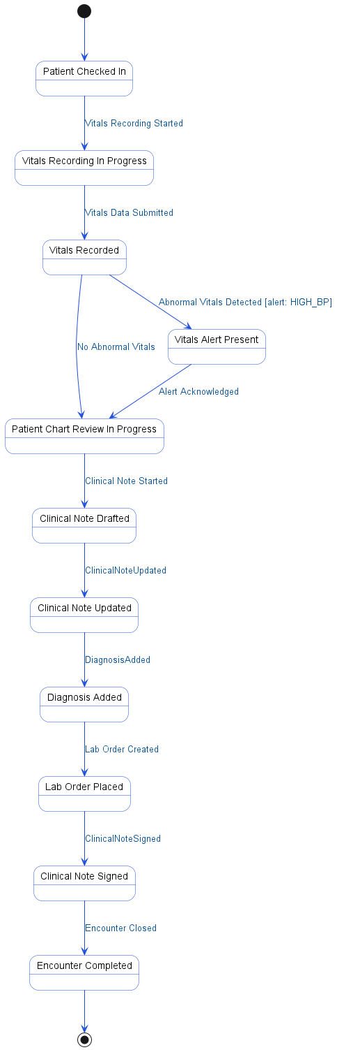

4.4. APIs Contract Agreement
# | Source | Destination | API | Protocol | Request Parameters | Response Parameters
1 | Physician Portal | Encounter Service | checkInPatient | REST | appointmentId | {checkedIn, room: 101}
2 | Encounter Service | Clinical DB | UPDATE appointments SET status = CHECKED_IN | JDBC
3 | Physician Portal | Vitals Service | recordVitals | REST | encounterId, vitalsData | Display alert
4 | Vitals Service | Clinical DB | INSERT vital_signs | JDBC
5 | Vitals Service | CDSS Engine | checkVitalsAlerts | REST | vitals | {alert: HIGH_BP}
6 | Physician Portal | Patient Service | getPatientSummary | REST | patientId | {summary, allergies: [Penicillin], activeProblems: [...]}
7 | Patient Service | Clinical DB | SELECT demographics, allergies, problems | JDBC |  | {patientData}
8 | Physician Portal | Vitals Service | getVitals | REST | encounterId | {vitals with BP alert}
9 | Physician Portal | Clinical Doc Service | createNote | REST | encounterId, type: PROGRESS | {noteId}
10 | Clinical Doc Service | Clinical DB | INSERT clinical_notes | JDBC | DRAFT
11 | Physician Portal | Clinical Doc Service | updateNote | REST | noteId, content | {signed}
12 | Clinical Doc Service | Clinical DB | UPDATE clinical_notes | JDBC
13 | Physician Portal | Problem List Service | addDiagnosis | REST | patientId, icd10: I10 | {added, recommendations}
14 | Problem List Service | Clinical DB | INSERT problem_list | JDBC
15 | Problem List Service | CDSS Engine | evaluateDiagnosis | REST | patientId, diagnosis | {recommendations: [Order metabolic panel, Consider ACE inhibitor]}
16 | Physician Portal | Order Service | createLabOrder | REST | encounterId, tests | {orderId, labNumber}
17 | Order Service | CDSS Engine | validateOrder | REST | order, patientData | {valid, no contraindications}
18 | Order Service | Lab Service | submitOrder | REST | labOrder | {submitted}
19 | Lab Service | Laboratory System | HL7 ORM^O01 | REST | Lab Order | {orderNumber: LAB-2025-001, status: RECEIVED}
20 | Order Service | Clinical DB | INSERT orders | JDBC
21 | Physician Portal | Clinical Doc Service | signNote | REST | noteId, physicianId
22 | Clinical Doc Service | Clinical DB | UPDATE clinical_notes SET status = SIGNED | JDBC
23 | Physician Portal | Encounter Service | closeEncounter | REST | encounterId | {closed}
24 | Encounter Service | Clinical DB | UPDATE encounters SET status = COMPLETED | JDBC
[*] Indicates that the data element is optional

4.5. Error Handling
# | Source | Destination | Scenario | Handling
1 | Physician Portal | Patient Service | getPatientSummary  Patient record not found in Patient Service | Return error code to upstream caller; Log error with correlation ID for traceability
2 | Physician Portal | Patient Service | getPatientSummary  Patient Service timeout when retrieving summary | Retry up to 3 times with exponential backoff; Log error with correlation ID for traceability; Return error code to upstream caller
3 | Physician Portal | Patient Service | getPatientSummary  Patient Service unavailable during summary retrieval | Activate circuit breaker, use fallback response; Log error with correlation ID for traceability; Notify operations team via alert if repeated
4 | Physician Portal | Vitals Service | getVitals  Vitals Service timeout when retrieving vitals | Retry up to 3 times with exponential backoff; Log error with correlation ID for traceability; Return error code to upstream caller
5 | Physician Portal | Vitals Service | getVitals  Vitals Service unavailable during vitals retrieval | Activate circuit breaker, use fallback response; Log error with correlation ID for traceability; Notify operations team via alert if repeated
6 | Physician Portal | Vitals Service | getVitals  No vitals data found for encounter | Return error code to upstream caller; Log error with correlation ID for traceability
7 | Physician Portal | Clinical Doc Service | createNote  Clinical Doc Service timeout during note creation | Ensure idempotency to avoid duplicates on retry; Retry up to 3 times with exponential backoff; Log error with correlation ID for traceability; Return error code to upstream caller
8 | Physician Portal | Clinical Doc Service | createNote  Clinical Doc Service unavailable during note creation | Ensure idempotency to avoid duplicates on retry; Activate circuit breaker, use fallback response; Log error with correlation ID for traceability; Notify operations team via alert if repeated
9 | Physician Portal | Clinical Doc Service | createNote  Duplicate note creation request detected | Ensure idempotency to avoid duplicates on retry; Return error code to upstream caller; Log error with correlation ID for traceability
10 | Physician Portal | Clinical Doc Service | updateNote  Clinical Doc Service timeout during note update | Retry up to 3 times with exponential backoff; Log error with correlation ID for traceability; Return error code to upstream caller
11 | Physician Portal | Clinical Doc Service | updateNote  Clinical Doc Service unavailable during note update | Activate circuit breaker, use fallback response; Log error with correlation ID for traceability; Notify operations team via alert if repeated
12 | Physician Portal | Problem List Service | addDiagnosis  Problem List Service timeout during diagnosis addition | Ensure idempotency to avoid duplicates on retry; Retry up to 3 times with exponential backoff; Log error with correlation ID for traceability; Return error code to upstream caller
13 | Physician Portal | Problem List Service | addDiagnosis  Problem List Service unavailable during diagnosis addition | Ensure idempotency to avoid duplicates on retry; Activate circuit breaker, use fallback response; Log error with correlation ID for traceability; Notify operations team via alert if repeated
14 | Physician Portal | Problem List Service | addDiagnosis  Duplicate diagnosis addition request detected | Ensure idempotency to avoid duplicates on retry; Return error code to upstream caller; Log error with correlation ID for traceability
15 | Physician Portal | Encounter Service | checkInPatient  Encounter Service timeout during patient check-in | Ensure idempotency to avoid duplicates on retry; Retry up to 3 times with exponential backoff; Log error with correlation ID for traceability; Return error code to upstream caller
16 | Physician Portal | Encounter Service | checkInPatient  Encounter Service unavailable during patient check-in | Ensure idempotency to avoid duplicates on retry; Activate circuit breaker, use fallback response; Log error with correlation ID for traceability; Notify operations team via alert if repeated
17 | Physician Portal | Encounter Service | checkInPatient  Duplicate check-in request detected | Ensure idempotency to avoid duplicates on retry; Return error code to upstream caller; Log error with correlation ID for traceability
18 | Physician Portal | Order Service | createLabOrder  Order Service timeout during lab order creation | Ensure idempotency to avoid duplicates on retry; Retry up to 3 times with exponential backoff; Log error with correlation ID for traceability; Return error code to upstream caller
19 | Physician Portal | Order Service | createLabOrder  Order Service unavailable during lab order creation | Ensure idempotency to avoid duplicates on retry; Activate circuit breaker, use fallback response; Log error with correlation ID for traceability; Notify operations team via alert if repeated
20 | Physician Portal | Order Service | createLabOrder  Duplicate lab order creation request detected | Ensure idempotency to avoid duplicates on retry; Return error code to upstream caller; Log error with correlation ID for traceability
21 | Order Service | Lab Service | submitOrder  Lab Service timeout during order submission | Ensure idempotency to avoid duplicates on retry; Retry up to 3 times with exponential backoff; Log error with correlation ID for traceability; Return error code to upstream caller
22 | Order Service | Lab Service | submitOrder  Lab Service unavailable during order submission | Ensure idempotency to avoid duplicates on retry; Activate circuit breaker, use fallback response; Log error with correlation ID for traceability; Notify operations team via alert if repeated
23 | Order Service | Lab Service | submitOrder  Duplicate lab order submission request detected | Ensure idempotency to avoid duplicates on retry; Return error code to upstream caller; Log error with correlation ID for traceability
24 | Lab Service | Laboratory System | HL7 ORM^O01  Laboratory System timeout during HL7 order message | Ensure idempotency to avoid duplicates on retry; Retry up to 3 times with exponential backoff; Log error with correlation ID for traceability; Queue request for asynchronous retry
25 | Lab Service | Laboratory System | HL7 ORM^O01  Laboratory System unavailable for HL7 order message | Ensure idempotency to avoid duplicates on retry; Activate circuit breaker, use fallback response; Log error with correlation ID for traceability; Notify operations team via alert if repeated
26 | Lab Service | Laboratory System | HL7 ORM^O01  Duplicate HL7 order message submission detected | Ensure idempotency to avoid duplicates on retry; Return error code to upstream caller; Log error with correlation ID for traceability
27 | Physician Portal | Clinical Doc Service | signNote  Clinical Doc Service timeout during note signing | Ensure idempotency to avoid duplicates on retry; Retry up to 3 times with exponential backoff; Log error with correlation ID for traceability; Return error code to upstream caller
28 | Physician Portal | Clinical Doc Service | signNote  Clinical Doc Service unavailable during note signing | Ensure idempotency to avoid duplicates on retry; Activate circuit breaker, use fallback response; Log error with correlation ID for traceability; Notify operations team via alert if repeated
29 | Physician Portal | Clinical Doc Service | signNote  Duplicate note signing request detected | Ensure idempotency to avoid duplicates on retry; Return error code to upstream caller; Log error with correlation ID for traceability
30 | Physician Portal | Encounter Service | closeEncounter  Encounter Service timeout during encounter closure | Ensure idempotency to avoid duplicates on retry; Retry up to 3 times with exponential backoff; Log error with correlation ID for traceability; Return error code to upstream caller
31 | Physician Portal | Encounter Service | closeEncounter  Encounter Service unavailable during encounter closure | Ensure idempotency to avoid duplicates on retry; Activate circuit breaker, use fallback response; Log error with correlation ID for traceability; Notify operations team via alert if repeated
32 | Physician Portal | Encounter Service | closeEncounter  Duplicate encounter closure request detected | Ensure idempotency to avoid duplicates on retry; Return error code to upstream caller; Log error with correlation ID for traceability

5. Electronic Prescription (e-Prescribing)

5.1. Sequence Diagram
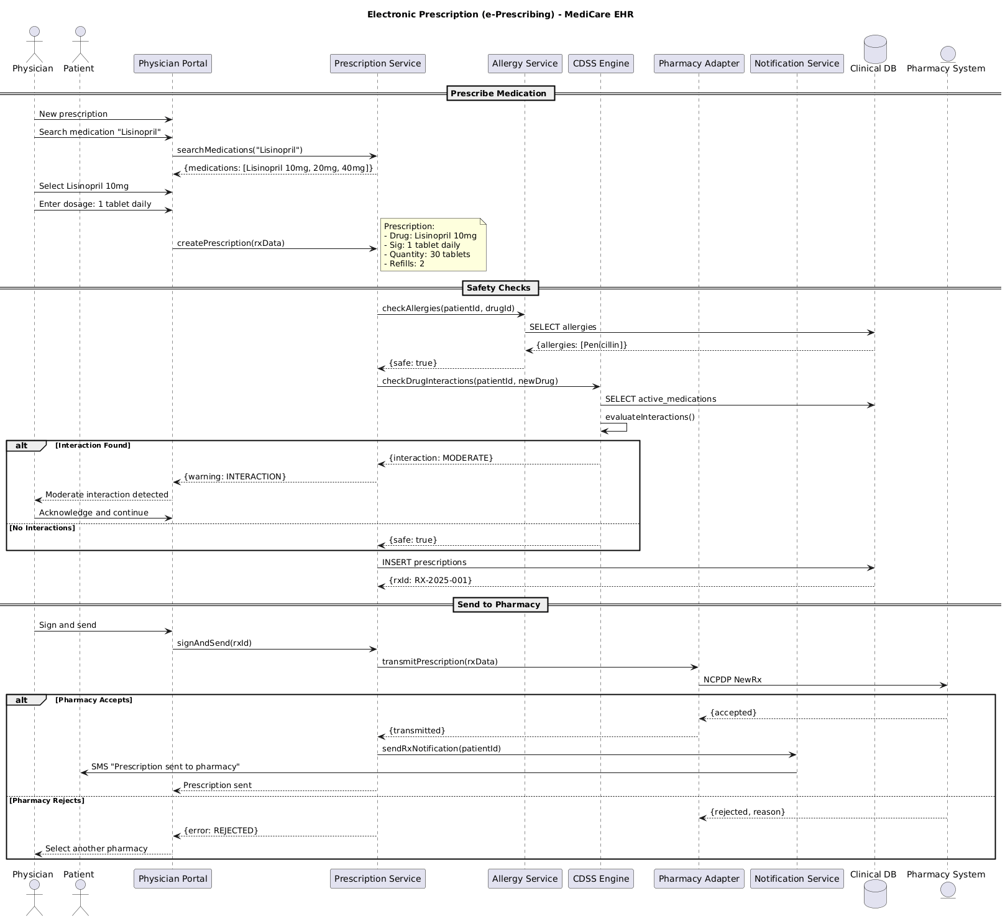

5.2. Flow Description
  - Overview
This flow describes the electronic prescription (e-Prescribing) process for the MediCare EHR platform. The main actors are Physician and Patient, who interact with the system through Physician Portal. The backend services involved include Prescription Service, Allergy Service, CDSS Engine, Pharmacy Adapter, Notification Service, Clinical DB, and Pharmacy System. The process covers medication selection, safety checks, prescription creation, and electronic transmission to a pharmacy, including all relevant control flows and exception handling.
  - Process Flow
Prescribe Medication
Physician initiates a new prescription through Physician Portal. Physician then searches for the medication "Lisinopril" using Physician Portal. Physician Portal forwards this search request to Prescription Service by invoking the searchMedications function with "Lisinopril" as the parameter. Prescription Service responds to Physician Portal with a list of available Lisinopril dosages: 10mg, 20mg, and 40mg.
Physician selects "Lisinopril 10mg" and enters the dosage instructions as "1 tablet daily" within Physician Portal. Physician Portal then calls Prescription Service to create the prescription, passing the relevant prescription data.
Note: Prescription:
- Drug: Lisinopril 10mg
- Sig: 1 tablet daily
- Quantity: 30 tablets
- Refills: 2
Safety Checks
Prescription Service requests Allergy Service to check for any allergies associated with the patient and the selected drug by providing the patient and drug identifiers. Allergy Service queries Clinical DB to retrieve the patient's recorded allergies. Clinical DB returns the allergy information, which in this case includes "Penicillin". Allergy Service responds to Prescription Service indicating that the prescription is safe for the patient.
Next, Prescription Service requests CDSS Engine to check for potential drug interactions by providing the patient identifier and the newly prescribed drug. CDSS Engine queries Clinical DB for the patient's active medications. CDSS Engine internally performs an evaluation of potential drug interactions.
If an interaction is found, CDSS Engine responds to Prescription Service with an interaction warning, specifying a moderate interaction. Prescription Service forwards this warning to Physician Portal, which then notifies Physician that a moderate interaction has been detected. Physician acknowledges the warning and instructs Physician Portal to continue with the prescription process.
If no interactions are detected, CDSS Engine responds to Prescription Service indicating that the prescription is safe.
Prescription Service then inserts the prescription record into Clinical DB. Clinical DB returns a unique prescription identifier to Prescription Service.
Send to Pharmacy
Physician initiates the signing and sending of the prescription through Physician Portal. Physician Portal calls Prescription Service to sign and send the prescription using the rxId. Prescription Service instructs Pharmacy Adapter to transmit the prescription data. Pharmacy Adapter forwards the prescription to Pharmacy System using the NCPDP NewRx standard.
If Pharmacy System accepts the prescription, it responds to Pharmacy Adapter with an acceptance message. Pharmacy Adapter informs Prescription Service that the prescription has been transmitted. Prescription Service then notifies Notification Service to send a prescription notification to the patient. Notification Service sends an SMS to Patient stating that the prescription has been sent to the pharmacy. Finally, Prescription Service confirms to Physician Portal that the prescription has been sent.
If Pharmacy System rejects the prescription, it responds to Pharmacy Adapter with a rejection message and the reason for rejection. Prescription Service informs Physician Portal of the error. Physician Portal then prompts Physician to select another pharmacy.
  - Authentication & Validation
CDSS Engine internally performs an evaluation of drug interactions as part of the safety checks.

5.3. State Machine Diagram
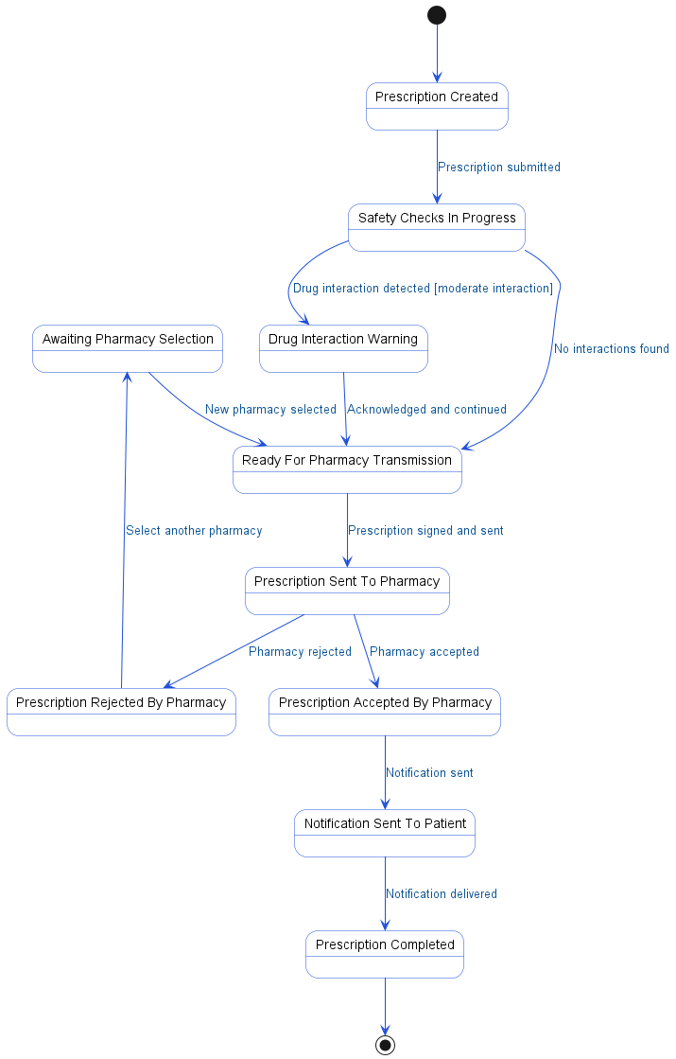

5.4. APIs Contract Agreement
# | Source | Destination | API | Protocol | Request Parameters | Response Parameters
1 | Physician Portal | Prescription Service | searchMedications | REST | "Lisinopril" | {medications: [Lisinopril 10mg, 20mg, 40mg]}
2 | Physician Portal | Prescription Service | createPrescription | REST | rxData | {warning: INTERACTION}
3 | Prescription Service | Allergy Service | checkAllergies | REST | patientId, drugId | {safe: true}
4 | Allergy Service | Clinical DB | SELECT allergies | JDBC |  | {allergies: [Penicillin]}
5 | Prescription Service | CDSS Engine | checkDrugInteractions | REST | patientId, newDrug | {interaction: MODERATE}
6 | CDSS Engine | Clinical DB | SELECT active_medications | JDBC
7 | Prescription Service | Clinical DB | INSERT prescriptions | JDBC |  | {rxId: RX-2025-001}
8 | Physician Portal | Prescription Service | signAndSend | REST | rxId | Prescription sent
9 | Prescription Service | Pharmacy Adapter | transmitPrescription | REST | rxData | {transmitted}
10 | Pharmacy Adapter | Pharmacy System | NCPDP NewRx | REST |  | {accepted}
11 | Prescription Service | Notification Service | sendRxNotification | REST | patientId
12 | Notification Service | Patient | SMS "Prescription sent to pharmacy" | REST
[*] Indicates that the data element is optional

5.5. Error Handling
# | Source | Destination | Scenario | Handling
1 | Physician Portal | Prescription Service | searchMedications  Prescription Service times out responding to searchMedications request | Retry up to 3 times with exponential backoff; Log error with correlation ID for traceability; Return error code to upstream caller
2 | Physician Portal | Prescription Service | searchMedications  Prescription Service unavailable during medication search | Retry up to 3 times with exponential backoff; Log error with correlation ID for traceability; Return error code to upstream caller
3 | Physician Portal | Prescription Service | searchMedications  Medication not found in Prescription Service database | Log error with correlation ID for traceability; Return error code to upstream caller
4 | Physician Portal | Prescription Service | createPrescription  Prescription Service times out creating prescription | Ensure idempotency to avoid duplicates on retry; Retry up to 3 times with exponential backoff; Log error with correlation ID for traceability; Return error code to upstream caller
5 | Physician Portal | Prescription Service | createPrescription  Prescription Service unavailable during prescription creation | Ensure idempotency to avoid duplicates on retry; Retry up to 3 times with exponential backoff; Log error with correlation ID for traceability; Return error code to upstream caller
6 | Physician Portal | Prescription Service | createPrescription  Duplicate prescription request received by Prescription Service | Ensure idempotency to avoid duplicates on retry; Log error with correlation ID for traceability; Return error code to upstream caller
7 | Physician Portal | Prescription Service | createPrescription  Validation failure in prescription data | Log error with correlation ID for traceability; Return error code to upstream caller
8 | Prescription Service | Allergy Service | checkAllergies  Allergy Service times out responding to checkAllergies request | Retry up to 3 times with exponential backoff; Log error with correlation ID for traceability; Return error code to upstream caller
9 | Prescription Service | Allergy Service | checkAllergies  Allergy Service unavailable during allergy check | Retry up to 3 times with exponential backoff; Log error with correlation ID for traceability; Return error code to upstream caller
10 | Prescription Service | Allergy Service | checkAllergies  Allergy data not found for patient | Log error with correlation ID for traceability; Return error code to upstream caller
11 | Prescription Service | CDSS Engine | checkDrugInteractions  CDSS Engine times out responding to drug interaction check | Retry up to 3 times with exponential backoff; Log error with correlation ID for traceability; Return error code to upstream caller
12 | Prescription Service | CDSS Engine | checkDrugInteractions  CDSS Engine unavailable during drug interaction check | Retry up to 3 times with exponential backoff; Log error with correlation ID for traceability; Return error code to upstream caller
13 | Prescription Service | CDSS Engine | checkDrugInteractions  No active medication data found for patient | Log error with correlation ID for traceability; Return error code to upstream caller
14 | Physician Portal | Prescription Service | signAndSend  Prescription Service times out during signAndSend operation | Ensure idempotency to avoid duplicates on retry; Retry up to 3 times with exponential backoff; Log error with correlation ID for traceability; Return error code to upstream caller
15 | Physician Portal | Prescription Service | signAndSend  Prescription Service unavailable during signAndSend operation | Ensure idempotency to avoid duplicates on retry; Retry up to 3 times with exponential backoff; Log error with correlation ID for traceability; Return error code to upstream caller
16 | Physician Portal | Prescription Service | signAndSend  Duplicate signAndSend request received by Prescription Service | Ensure idempotency to avoid duplicates on retry; Log error with correlation ID for traceability; Return error code to upstream caller
17 | Physician Portal | Prescription Service | signAndSend  Validation failure in signAndSend request | Log error with correlation ID for traceability; Return error code to upstream caller
18 | Prescription Service | Pharmacy Adapter | transmitPrescription  Pharmacy Adapter times out during prescription transmission | Ensure idempotency to avoid duplicates on retry; Retry up to 3 times with exponential backoff; Log error with correlation ID for traceability; Queue request for asynchronous retry
19 | Prescription Service | Pharmacy Adapter | transmitPrescription  Pharmacy Adapter unavailable during prescription transmission | Ensure idempotency to avoid duplicates on retry; Retry up to 3 times with exponential backoff; Log error with correlation ID for traceability; Queue request for asynchronous retry
20 | Prescription Service | Pharmacy Adapter | transmitPrescription  Duplicate prescription transmission request received by Pharmacy Adapter | Ensure idempotency to avoid duplicates on retry; Log error with correlation ID for traceability; Return error code to upstream caller
21 | Prescription Service | Pharmacy Adapter | transmitPrescription  Validation failure in prescription transmission request | Log error with correlation ID for traceability; Return error code to upstream caller
22 | Prescription Service | Notification Service | sendRxNotification  Notification Service times out sending notification | Retry up to 3 times with exponential backoff; Log error with correlation ID for traceability; Queue request for asynchronous retry
23 | Prescription Service | Notification Service | sendRxNotification  Notification Service unavailable during notification sending | Retry up to 3 times with exponential backoff; Log error with correlation ID for traceability; Queue request for asynchronous retry
24 | Prescription Service | Notification Service | sendRxNotification  Duplicate notification request received by Notification Service | Ensure idempotency to avoid duplicates on retry; Log error with correlation ID for traceability; Return error code to upstream caller
25 | Prescription Service | Notification Service | sendRxNotification  Validation failure in notification request | Log error with correlation ID for traceability; Return error code to upstream caller

6. Appendix

6.1. Patient Clinical Encounter Data Elements
# | Service Name | Data Element | Description
1 | checkInPatient (Request) | appointmentId | Unique identifier for the patient appointment
2 | checkInPatient (Response) | checkedIn | Indicates patient check-in status
3 | checkInPatient (Response) | room | Assigned room number for the patient
4 | recordVitals (Request) | encounterId | Unique identifier for the clinical encounter
5 | recordVitals (Request) | vitalsData | Collection of vital signs recorded for the patient
6 | checkVitalsAlerts (Request) | vitals | Vital signs data sent for alert evaluation
7 | checkVitalsAlerts (Response) | alert | Alert code indicating abnormal vital sign detected
8 | getPatientSummary (Request) | patientId | Unique identifier for the patient
9 | getPatientSummary (Response) | summary | Summary of patient demographics and clinical data
10 | getPatientSummary (Response) | allergies | List of patient allergies
11 | getPatientSummary (Response) | activeProblems | List of patient’s active medical problems
12 | getVitals (Request) | encounterId | Unique identifier for the clinical encounter
13 | getVitals (Response) | vitals | Vital signs data for the encounter
14 | getVitals (Response) | BP alert | Blood pressure alert indicator
15 | createNote (Request) | encounterId | Unique identifier for the clinical encounter
16 | createNote (Request) | type | Type of clinical note being created
17 | createNote (Response) | noteId | Unique identifier for the clinical note
18 | updateNote (Request) | noteId | Unique identifier for the clinical note
19 | updateNote (Request) | content | Content of the clinical note
20 | addDiagnosis (Request) | patientId | Unique identifier for the patient
21 | addDiagnosis (Request) | icd10 | ICD-10 diagnosis code
22 | evaluateDiagnosis (Request) | patientId | Unique identifier for the patient
23 | evaluateDiagnosis (Request) | diagnosis | Diagnosis information to be evaluated
24 | evaluateDiagnosis (Response) | recommendations | List of clinical recommendations based on diagnosis
25 | createLabOrder (Request) | encounterId | Unique identifier for the clinical encounter
26 | createLabOrder (Request) | tests | List of lab tests to be ordered
27 | validateOrder (Request) | order | Lab order details for validation
28 | validateOrder (Request) | patientData | Patient data relevant for order validation
29 | validateOrder (Response) | valid | Indicates if the order is valid
30 | validateOrder (Response) | no contraindications | Indicates absence of contraindications for the order
31 | submitOrder (Request) | labOrder | Lab order details to be submitted
32 | HL7 ORM^O01 (Lab Order) (Response) | orderNumber | Unique identifier for the lab order
33 | HL7 ORM^O01 (Lab Order) (Response) | status | Current status of the lab order
34 | createLabOrder (Response) | orderId | Unique identifier for the created lab order
35 | createLabOrder (Response) | labNumber | Laboratory system order number
36 | signNote (Request) | noteId | Unique identifier for the clinical note
37 | signNote (Request) | physicianId | Unique identifier for the physician
38 | closeEncounter (Request) | encounterId | Unique identifier for the clinical encounter

6.2. Electronic Prescription (e-Prescribing) Data Elements
# | Service Name | Data Element | Description
1 | searchMedications (Request) | "Lisinopril" | Medication name to search in formulary
2 | searchMedications (Response) | medications | List of available medication options matching search
3 | createPrescription (Request) | rxData | Prescription details including drug, dosage, quantity, and refills
4 | checkAllergies (Request) | patientId | Unique identifier for the patient
5 | checkAllergies (Request) | drugId | Unique identifier for the prescribed drug
6 | checkAllergies (Response) | safe | Indicates if prescribed drug is safe for patient allergies
7 | checkDrugInteractions (Request) | patientId | Unique identifier for the patient
8 | checkDrugInteractions (Request) | newDrug | Drug being newly prescribed for interaction check
9 | checkDrugInteractions (Response) | interaction | Level of drug interaction detected (e.g., MODERATE)
10 | checkDrugInteractions (Response) | safe | Indicates if new drug is safe with current medications
11 | INSERT prescriptions (Response) | rxId | Unique identifier for the created prescription
12 | signAndSend (Request) | rxId | Unique identifier for the prescription being sent
13 | transmitPrescription (Request) | rxData | Prescription details to be transmitted to pharmacy
14 | transmitPrescription (Response) | accepted | Indicates prescription was accepted by pharmacy
15 | transmitPrescription (Response) | rejected | Indicates prescription was rejected by pharmacy
16 | transmitPrescription (Response) | reason | Reason for prescription rejection by pharmacy
17 | sendRxNotification (Request) | patientId | Unique identifier for the patient to notify
18 | sendRxNotification (Response) | SMS | SMS message content sent to patient
19 | (Response) | warning | Warning message indicating drug interaction
20 | (Response) | error | Error code or message for rejected prescription

6.3. Solution Architecture Reference Documents
# | Name | File
1 | BRD | Refer to Latest BRD Attached to JIRA Ticket

